COP25 Week One - Report for SCCS Members only

As you know, we have a good number of SCCS members at the COP25 summit this year. All the others are fulfilling roles within their own international networks as well as representing SCCS, while I am here specifically to get my head around how the COP, and associated activities, work. The main parts of this are:
- ‘The Blue Zone’ the official COP –where you need a badge to enter
- ‘The Green Zone’, a space that is usually provided alongside that the public can enter – this is where you find a lot of school parties and the general public of Madrid.
- The Mobilisation
- The civil-society organised spaces – which, in Madrid, are a social summit running all this week (started Saturday) and the ‘convergent space’ where campaigners can find office space, meeting space and other resources to help them.

This week 1 report is to update on the work that SCCS has been doing at the COP. If you are interested in keeping track of progress and negotiations of COP25 then reading the CAN ECO newsletters will help.

First Impressions:
The COP badged space is absolutely huge with a vast (imagine aircraft hangar) reception space containing a few talks zones, and also tiny stalls for groups to rent for a day or more as well as country delegation private office/meeting spaces. There is a second massive space with non-country pavilions (like the WWF pavilion, the IPCC, various others) and then there is a third space for country pavilions, a fourth for negotiating spaces – each of which is pretty huge – especially the plenary one. And a couple of vast halls where temporary rooms have been constructed that some groups can book for meetings, press conferences and the like. Behind the scenes there are yet more rooms for negotiators and delegations
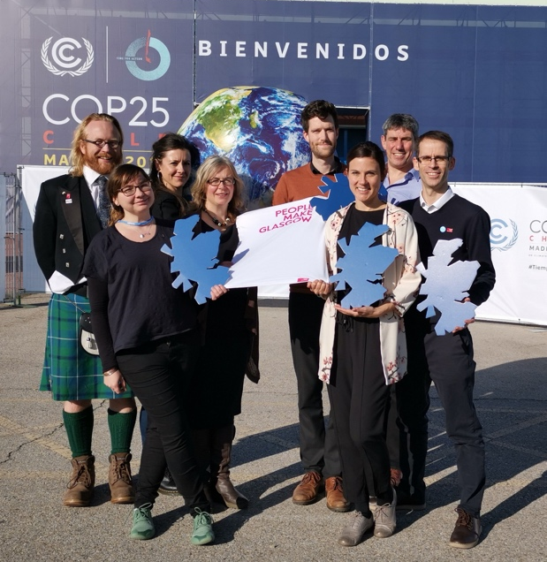
It is airless, has no natural light, the acoustics are debilitatingly bad (impossible to make conference calls in) and many people spend all day every day in here – with receptions and activities extending well into the evening. There are hundreds and hundreds of parallel events taking place all day and it is a huge challenge to find out where the best place for you to be is at any one time. Most people do it by word of mouth as the choice is truly mind-blowing.

After a first day of utter confusion, disorientation and downright bewilderment I started to find my feet on Wednesday, with the help of SCCS colleagues. And now I have really got into my stride with a number of very good discussions and chats with people I have come across here, and starting to get my head around what SCCS role could be for COP26.

I have also discovered the full diversity of the global climate movement both within the COP badged space, and the social summit space. For example, the most powerful press conference have been to was hosted by Friends of the Earth International and given by indigenous people who talked extremely powerfully, and transformatively.

What have you been doing Kat?
I have been shadowing our SCCS members in turn to learn more about how civil society groups try and make a difference to what is going on in the COP. This has been very useful, especially to see the diverse global alliances that our Scottish colleagues have links with. In addition to this I have been at the GB pavilion, made good connections there with UK people, met Scientists, and indigenous representatives and explored all the other pavilions and spaces.

On Wednesday WWF and SCCS hosted Councillor Susan Aitken, Leader of Glasgow City Council. Susan gave a great introduction where she touched on many many of the themes in our framing document for the civil society side of the COP – and referred to the ‘Glasgow Spirit’ of welcome. She had a very useful meeting with us and colleagues from the global south, where we were advocating for her to use levers to ensure representation from those voices most affected by climate change at the COP. We hope we will have opportunity to follow up this great meeting back in Glasgow. WWF also ensured that she met a variety of very useful people while she was at COP including the leader of CAN (Climate Action Network), International Trade Union Congress, and the COP25 Presidency.
See Jamie’s interview with Councillor Aitken here:

SCCS met with the Minister Roseanna Cunningham today. She took our climate justice fund ask well and said she will bear it in mind in budget discussions with Swinney. We were really encouraged by her commitment to do all she can to frontline voices from global south at COP26, and to use any diplomatic influence they have to help with visas. She also invited us to get involved in a programme for the science centre. We also met with people from the CAN network (Tom Boyle - CAN Europe, and Jana Merkelbach CAN International) to talk about how we can work together to ensure the best impact of civil society on Cop in 2020.

But it has not just been at the COP itself, I have been spending time at the Social Summit and learning about how they have managed to put on such a full and well-organised event in such a short space of time. I am speaking to the organisers and various groups that are here to support the work.

We have run two events at the social summit to invite participants to find out about some of the political background, challenges and opportunities of a COP in Glasgow, and to listen to advice and ideas – as many of these people are COP veterans. On each of these we have brought someone in from the wider COP26 coalition from the UK to give the UK and international context and express that we are working across a very broad an inclusive collation. These have been extremely useful.

I also attended the Mass Mobilisation and had the useful standpoint of waiting ahead of the march to see it all pass by and join my SCCS colleagues once their sectors came past. A line of two representatives of each group walking shoulder-to-shoulder started off and then, leading the march, were by the indigenous groups, walking in silence with a flame ahead of them. It was extremely moving and powerful to see. It was so well organised you would never have known that they only had a month. Afterwards I met one of the organisers who is happy to speak to those organising the Glasgow march.

Press and Media
We have put out a number of blogs which you can see on our website – and there are more to come, most of which have made it into the media – see links below. We submitted press releases at the start of the COP, ahead of the mobilization, and we have one with the development organisation members on Climate Finance to go out this week.

- Op Ed in Scotsman from Oxfam, SCIAF, Christian Aid and SCCS
https://www.scotsman.com/news/environment/farmer-from-malawi-brings-global-climate-crisis-closer-to-home-than-madrid-1-5058846

- FoES piece on Carbon Markets published in the Scotsman https://www.scotsman.com/news/opinion/columnists/why-oil-industry-must-be-kicked-out-of-climate-change-talks-mary-church-1-5059189

- SCCS in Third Force News. https://thirdforcenews.org.uk/tfn-news/scotland-urges-world-leaders-to-wake-up-to-climate-change

- Look out for Nature and Climate piece by WWF/RSPB in Herald on 11th

- More coverage by our members
https://www.bbc.com/news/uk-scotland-50706068

https://www.heraldscotland.com/news/18073457.glasgow-un-summit-must-climate-crisis-turning-point/

The week ahead:
I have discovered how interested people are in talking about Glasgow and I am getting more and more requests to meet with folks, and so I expect to do quite a bit of this next week, as well as spending some time with the director for Neighbourhoods and Sustainability of Glasgow City council who is here for a few days. I also have a meeting with Neil Thorns of TCC tomorrow to coordinate. Our SCCS colleagues here are working hard communicating what SCCS does and sharing intelligence on Glasgow, the planning so far etc., in their own networks, and we hope to get a session at the CAN daily briefing this week. Critical is how we can help create a civil society interaction for COP that is effective and this is where I am concentrating my attention.

We also have a presence at the social summit plenary towards the end of the week – where we ‘receive the baton’ and will rally civil society to join us in Glasgow, and where we will invite the whole social summit to join us in a few ceilidh dances. (I believe a progressive Circassian Circle represents best our plans for a connecting, involving, sharing and creative space for civil society at the COP…)

All the best from

Kat and the SCCS team at COP25

